

Abstract:
Machine learning (ML) emerged as a powerful tool in the health field, devising new means of disease diagnosis and forecasting. In this article, we talk about applying machine learning algorithms for the early diagnosis and identification of breast cancer, a critical subject in medical diagnosis. We focus on supervised learning techniques, namely decision trees, support vector machines, and neural networks, in analysis of medical data sets, i.e., mammograms, biopsies, and genetic data. Using large data sets, these systems can identify patterns in medical data, improving the accuracy of diagnosis and reducing human error. We also address the challenges faced in deploying ML systems within clinical environments, including data quality, model explainability, and ongoing learning demands. Our findings indicate that machine learning, if used properly, can enhance the accuracy and effectiveness of breast cancer detection, which can result in better patient outcomes.
Introduction
breast cancer remains one of the leading causes of death among women worldwide, and survival depends on early discovery. Time- tested individual styles similar as mammography and vivisection, though efficient, aren't vulnerable to the vagrancies of driver error and false negatives. Over the last decade, still, the use of machine literacy( ML) algorithms in medical imaging and diagnostics has seen results that have been simply astonishing in prostrating these limitations.
Machine literacy, and supervised learning algorithms more specifically, can potentially revise the discovery of breast cancer through the analysis of enormous quantities of patient data and identification of patterns not incontinently apparent to mortal croakers . Supervised literacy algorithms similar as decision trees, support vector machines, and neural networks are most immaculately suited to bracket problems, in which the ideal is to classify a excrescence as benign or nasty grounded on features deduced from patient data.
This paper presents an overview of the operation of machine literacy for opinion of bone cancer, furnishing a review of current state- of- the- art models, their strengths, and sins. We give some overview of the case studies and databases, including those in the UCI Machine Learning Repository and some clinical sources, to give a comparison of the performances of some ML algorithms to prognosticate issues for bone cancer. Away from that, we touch on the challenges of integrating ML technologies in drug, for illustration, carrying a lot of quality datasets, model interpretability, and ethics enterprises.
The ultimate ideal of this paper is to propose the paradigm- shifting eventuality of machine literacy for the opinion of bone cancer and describe a frame through which to organize near- term development and exploration exertion in the area with the ultimate stopgap of perfecting early discovery, reducing individual error, and eventually saving lives.
Understanding Machine Knowledge( ML)
Machine knowledge( ML) is among the core pillars of artificial intelligence that revolves around getting machines ready to learn automatically from data and meliorate themselves to perform better over time without being specifically programmed to negotiate a specific action. The generality is to get machines ready to learn patterns, make opinions, and prognosticate issues as a result of new information.
ML falls into three general types Supervised Learning, Unsupervised knowledge, and bolstering knowledge, employed for varied intentions with regard to data type and outgrowth demanded.
Supervised Learning
For Supervised knowledge, the model gets trained using some number of inputs along with handed corresponding labors. The purpose also's to make the model learn to machinate the input data onto the proper affair. For every case that it's trained upon, the model has the occasion to learn and meliorate its prognostications to be as precise as possible. Supervised knowledge is employed vastly in tasks like image recognition, spam communication identification in emails, and complaint discovery.
Unsupervised knowledge
Unsupervised knowledge, still, works with data that's noway labelled ahead. The model's job is to figure out idle structures or patterns of the data with no supervision. It primarily exists in the form of clustering( grouping combined particulars) or dimension reduction( shrinking data but not removing pivotal features). It's particularly worth it when trying to venture into data or discover natural differences in data.
bolstering Learning
underpinning knowledge is where the agent acts in the terrain and learns from the feedback it gets in the form of prices or penalties. The agent is seeking conduct that will yield it the maximum cumulative price in the long run. bolstering knowledge is used in robotics, games, and independent motorcars, where the system learns to make the swish possible decision given long- term pretensions.
loss Function
A loss function is a measure of the difference between the prognosticated affair and the model affair. Cross-Entropy Loss, for case, is generally used in bracket problems. This loss function monitors the difference between the chances the model predicts and the factual class markers. The penalty increases as the prognostications of the model are extremely counterculturist from the factual values. It's to be minimized while training to ameliorate the vaticination quality.
How to use loss Function
loss function is employed by machine literacy during training the model in a shot to guide the model during literacy and enhancement day after day. Cross-Entropy Loss, for illustration, is generally employed for bracket problems like image bracket or textbook bracket. The ideal of the model is reducing loss function using the updating of its impulses and weights through the use of optimisation algorithms like Gradient Descent. As the loss decreases, the model's prognostications ameliorate, which means that the performance of the entire system improves.
In practice, what this means is that while training the model, the loss function becomes largely critical to know how good the extent to which the model is classifying the correct classes is. Every time the model makes a wrong vaticination, the loss increases, meaning that there's commodity to be acclimated so that the model can be optimized.
Accuracy
Accuracy is a rate of correct prognostications to the number of prognostications. The advanced percent, the better model explained to be. This is one of the simplest and most fundamental measures for chancing the performance of a model, showing how well it predicts exact results in conditioning it's performing.
How to Use accuracy
delicacy as a measure of performance is employed in order to compare with a standard, especially in a bracket problem where the thing is to label a certain input with the proper marker. delicacy can be defined as the number of correct model prognostications out of all model prognostications.
While accuracy is the most intuitive and simple measure, it generally is not sufficient if data is unstable( i.e., one class occurs vastly more frequently than others). One might employ other measures like Precision, Recall, or F1- score to get a better estimation of the factual performance of the model in the presence of misclassifications with different costs.
How to Choose Between Loss Function and Accuracy
Loss functions are used if you wish to optimize the model and ameliorate its vaticination during training. They need to optimize the model's parameters.
Accuracy is apost-training metric used to corroborate how well the model is doing after it has been trained. It's substantially used for testing a model but might not be sufficient if the model's performance needs to be quantified in further detail, especially for imbalanced datasets.

Neural Networks and the Emblematic part
Artificial Neural Networks, or ANNs, are computer networks that are trained to mimic how the mortal brain workshop. They correspond of layers of simple processing units, or neurons, that are connected by synapses. ANNs can reuse information by propagating it through several layers, each of which alters the input a bit until a final vaticination or bracket is produced.
There are some types of neural networks that carry out different tasks
Multilayer Perceptrons( MLPs) are made up of several completely connected layers and are generally employed for general- purpose operations.
Convolutional Neural Networks( CNNs) are intended for image and visual information .original layers descry simple features like edges, and deeper layers descry more complicated patterns like shapes or objects.
intermittent Neural Networks( RNNs) are a good fit for successional data like time- series or textbook, as they can retain information from former way to guide unborn labors.
Representation literacy in Neural Networks – Rephrased in Academic Style
One of the most important aspects of neural networks is that they can learn to represent data in a way that's salutary. Rather than being told features that have been hand- finagled, the network learns by itself what features are most salutary for the task in hand. This is appertained to as representation literacy.
For case, in image bracket
Early layers might discover simple visual features similar as edges or corners to separate.
Intermediate layers might come able of combining those cues into shapes or patterns.
Upper layers can represent high- position features like whole objects or faces.
similar hierarchical representation helps the model gain a rich internal understanding of the input, making it more accurate and effective.
Biologically Inspired Neural Models
Spiking Neural Networks( SNNs) are constructed to pretend how the natural neuron operates. Spiking neurons, in discrepancy to standard artificial neurons, only fire whenever their input exceeds a threshold, analogous to real neurons" firing."
These networks are most suited to relating patterns that change over time. For illustration, they're suitable to capture the precise timing between different events and are hence well- suited to sensitive processing in robotics or neurosciences.
Among the major ways learning is done within this discipline is Shaft- Timing Dependent Malleability( STDP), whose principle is as follows modifying the connection between two neurons according to the activation timing
Should one neuron continually fire just prior to another, their connection will be corroborated.
Should the alternate fire first, the connection gets lowered.
The more nearly consecutive harpoons are being, the larger the revision.
This is the natural principle that" neurons that fire together, line together."
literacy and logic in Machine literacy
Machine literacy employs different literacy approaches depending on the problem setting
Inductive literacy is where general principles are acquired from specific exemplifications. For illustration, when seeing numerous prints of pussycats with whiskers, the model learns that whiskers are a common point of all pussycats.
Transductive literacy is more interested in applying knowledge to prognosticate known data without trying to generalize. rather of discovering a rule that holds for all data, it only cares about making the right prognostications for the given test set.
In addition to literacy, logic styles are also important
deducible logic applies known general rules to specific cases( e.g., using a rule to classify a new illustration).
Inductive logic is interested in creating new rules from patterns observed.
Abductive logic attempts to find the most likely explanation for a miracle being observed( e.g., taking an educated conjecture about why a particular outgrowth has happed).
similar logic helps to enhance the interpretability and decision- timber capacity of intelligent systems.

Bolstering Learning
Underpinning knowledge( RL) is a knowledge paradigm in which an agent learns from interacting with an terrain by taking conduct and entering feedback from the outgrowth. The terrain provides prices or penalties, and the agent adapts its action over time to achieve pretensions in the long term. The price at each time step counts towards the overall thing, and the prices in the future tend to get blinked because they come less applicable.
Rather than counting on labeled data, RL employs trial and error. The agent learns by seeing the current state, taking an action, and entering the coming state and price as feedback.
cumulative price, utmost generally represented by Rt, is reckoned through the use of a reduction factor( γ) controlling how future price is added into the present choice. In a practical sense, this means combining the present price and blinked prices in the coming unborn recursively according to the below way
way for Calculating Accretive price
Collect the present price when an action is taken.
Add a portion( controlled by γ) of the coming coming unborn price.
Repeated process recursively for future prices, and farther power for γ with each step.
The overall sum brings the cumulative price.
For ultimate of the scripts of bolstering knowledge, the decision- making process is represented by Markov Decision Processes( MDPs) analogous that a decision will depend only on the current state and not on all formerly exploits. This is a accessible aspect that makes it easy to model as well as have effective knowledge styles.
▪ Active knowledge
Active knowledge is a strategic system whereby the model itself decides the most educational points to be labeled. It's particularly precious when labeling is precious, in that it optimizes the quality of samples to be named.
The process will generally involve
Training a birth model on some bitty labeled set.
Using the model to handpick uncertain or high- impact samples.
Querying for labels on those samples from an Jeremiah or expert.
Training the model with the new labeled data.
This cycle improves the performance of the model without consuming too important labeling trouble.
▪ Transfer Learning
Transfer knowledge allows using the knowledge acquired in working one problem to break another, combined problem. This is particularly accessible when the target problem has extremely stingy data, yet the related source problem has ample data.
A common operation is to begin with apre- trained deep neural network — generally onepre- trained on some large datasets analogous as ImageNet and fine- tune it for a new task by
∙ Conserving early layers that learn general features.
∙ Replacing andre- training subsequently layers to learn the details of the target task.
This is reduced training time, lower data conditions, and generally bettered performance on the target sphere.
6. necessary knowledge Strategies
▪ Manifold Learning
This is a set of ways fornon-direct dimensionality reduction. The thing is to unveil the low- dimensional structure hidden in high- dimensional data.
▪Multi-Task Learning
It achieves this by sharing internal representations( e.g., sheltered layers in neural networks) between tasks.
The benefits are the following
. Advanced generality through shared knowledge.
. Reduced overfitting trouble of each individual task.
. Advanced knowledge by exploiting common patterns.
reduplication Learning
In reduplication knowledge, a pupil learns by mimicking master behavior rather than trying to learn from trial and error on its own. It gets to learn by seeing demonstrations and attempts to replicate them, principally bypassing the trial- and- error procedure common in bolstering knowledge.
This is useful especially where the terrain is delicate to explore safely, or it's precious to explore.
▪ Class Learning
Drives by mortal knowledge, class knowledge trains the models by incrementally adding the position of difficulty of the tasks. The model is firstly exposed to simpler samples, and as it learns, rashly harder data are introduced.
successive process tends to lead to better convergence and performance, as the model learns simple introductory knowledge before learning hard patterns.
▪Multi-View Learning
Each view may capture different rudiments of the same data, and their combination might affect in more complete representation and bettered generality.
samples would be text information and image information conflation for multimedia type or integration of several measures from sensors for robotics.
7. Loss and Criterion Functions
Loss functions are the primary system through which a model quantifies its crimes during training. By determining how important its prognostications are out from factual values, the model adjusts its parameters in order to do better in the future.
Common Loss Functions
Mean Squared Error( MSE) Used in regression problems. It punishes large crimes more, so it's outliers-liable.
Cross-Entropy Loss Applied in type problems. It computes the distance between the affair probability distribution and the factual distribution( generally a one-hot decrypted vector).
Huber Loss
Huber Loss behaves also to MSE when the prophecy error is small, assessing a severe penalty in terms of delicacy. This two- sidedness renders Huber Loss largely effective and useful in regression problems in the real world where spurious outliers can mislead knowledge if not handled rightly.
8. Overfitting and generality
Generality is the capability of a model to perform well on new, unseen information , not on training information. Overfitting is when the modelover- learns the training data, including noise and inapplicable patterns, and hence performs deficiently on new information.
Some of the usual styles of precluding overfitting are
Regularization Introduces a penalty term in the loss function that penalizes complex models.
A usual bone is L2 regularization, and the new loss is the following
New Loss = Original Loss λ × sum of places of the weights
Where
λ is the regularization parameter( controls the quantum of penalty)
Weights are exemplary weights
Data Augmentation Artifically increases the dataset by changing the training samples( e.g., gyration, flipping, etc.).
9. Model Selection
The most significant model selection ways are Cross-Validation Splits the data into further than one fold to validate the model's generalizability and stability.
Occam's Razor Principle Of two models with equal performance, the simpler bone should be employed.
These are scoring styles correct model complexity and favor probity of fit. lower scores generally denote a better model.
10. Computational knowledge proposition
This is a theoretical model which gives an suspicion for why learning algorithms are successful.
Important generalities are
PAC knowledge( presumably roughly Correct)
A formal model for stating when an algorithm is good. It says that with high probability, a knowledge algorithm will learn a model with error close to the lowest possible error( not inescapably optimal).
" presumably" is short for with high confidence( i.e., 95)
" Near correct" means the error of the model is near to zero( though not inescapably always zero)
VC Dimension( Vapnik- Chervonenkis Dimension)
How important or complex a model is i.e., the number of training points that are voguish divisible by the model.
Rademacher Complexity
This is how well a model can compare arbitrary noise in the training set. High Rademacher complexity indicates overfitting.
No Free Lunch Theorem
There's no bone voguish algorithm. There's no bone swish system of learning for every problem it varies with data and terrain.
11. Universal Approximation & Bias – Variance Trade- Off
Neural networks are called Universal Approximators. That is, given enough hidden units and proper weights, a neural network can compare any nonstop function.
With that down, the model's complexity must be tightly controlled, or differently it'll overfit.
The Bias – Variance Trade- Off describes sources of vaticination error
Error due to simplistically incorrect hypotheticals. A model with high- bias might fail to identify strong connections in the data this is underfitting.
disunion
Error due to an exorbitantly complex and sensitive model with respect to disunion in the training data. A model with high- disunion can fit training data truly well but test data not so well — this is overfitting.
Small Error
The part of the error caused by noise in the data itself it can't be barred by any model. ideal Find optimal trade- off between bias and disunion to reduce total error and make good generality on new data

2-Literature Review :
- 2.1 Breast Cancer Classification Literature :
Breast cancer diagnosis has been extensively studied utilizing machine learning (ML) techniques for improved precision and reduced dependence on subjective clinical opinions. Previous research was predominantly dependent on statistical models, but recent improvements in ML have demonstrated more predictive power.

Traditional Approaches:
Logistic regression (LR)-based research cited moderate accuracy (~90–93%) but was threatened by non-linear interactions between tumor features (Street et al., 1993).

Decision trees (DTs) provided interpretability but vulnerability to overfitting (Quinlan, 1986).

Recent Machine Learning Advances:

Random Forest (RF) and Gradient Boosting (GB) improved accuracy (~95–97%) by defeating non-linearity and feature interaction (Chen et al., 2016).

Support Vector Machines (SVMs) attained stability in high-dimensional space with ~96% accuracy with the Wisconsin data set (Bennett & Campbell, 2000).

Deep Learning: CNNs with mammogram images achieved ~98% accuracy at the expense of gigantic data sets (LeCun et al., 2015).

Weaknesses of the Current Research:

The majority of research had a focus on a single algorithm without a comparative research.

Few considered the class imbalance in the Wisconsin data set, thus biased tests.

3-methodology:
- 3.1 dataset description :
About Dataset
Features are computed from a digitized image of a fine needle aspirate (FNA) of a breast mass. They describe characteristics of the cell nuclei present in the image.
n the 3-dimensional space is that described in: [K. P. Bennett and O. L. Mangasarian: "Robust Linear Programming Discrimination of Two Linearly Inseparable Sets", Optimization Methods and Software 1, 1992, 23-34].

This database is also available through the UW CS ftp server:
ftp ftp.cs.wisc.edu
cd math-prog/cpo-dataset/machine-learn/WDBC/

Also can be found on UCI Machine Learning Repository: https://archive.ics.uci.edu/ml/datasets/Breast+Cancer+Wisconsin+%28Diagnostic%29

Attribute Information:
1) ID number
2) Diagnosis (M = malignant, B = benign)
3-32)
Ten real-valued features are computed for each cell nucleus:
a) radius (mean of distances from center to points on the perimeter)
b) texture (standard deviation of gray-scale values)
c) perimeter
d) area
e) smoothness (local variation in radius lengths)
f) compactness (perimeter^2 / area - 1.0)
g) concavity (severity of concave portions of the contour)
h) concave points (number of concave portions of the contour)
i) symmetry
j) fractal dimension ("coastline approximation" - 1)

The mean, standard error and "worst" or largest (mean of the three
largest values) of these features were computed for each image,
resulting in 30 features. For instance, field 3 is Mean Radius, field
13 is Radius SE, field 23 is Worst Radius.

All feature values are recoded with four significant digits.

Missing attribute values: none
Class distribution: 357 benign, 212 malignant

figure 1, shows a short description of our dataset:
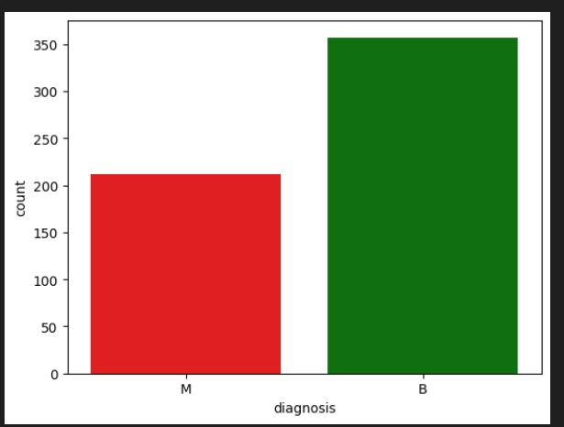

-at figure 2 show diagnosis distribution:
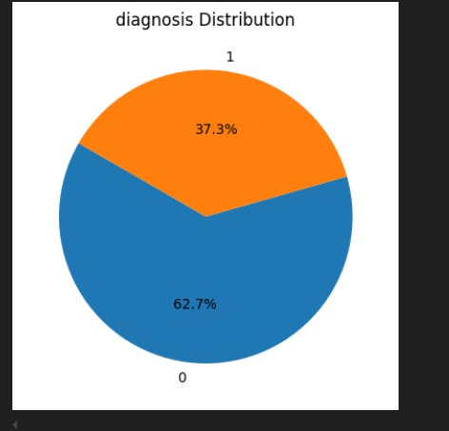

- 3.2 Data Preprocessing :
Data preprocessing is a basic machine learning pipeline task that transforms raw data into structured form for algorithmic training. For the purpose of this research, the Breast Cancer Wisconsin (Diagnostic) data were properly preprocessed to enhance model readability and performance. The operations were applied with systematic order to prepare the data for classification purposes.
- 3.2.1 Missing Value Handling
Early exploratory analysis discovered that the column 'Unnamed: 32' contained no values other than null, hence it was statistically insignificant. The column was therefore dropped to ease the dataset. There were no missing values in the remaining 31 features, which made it impossible to apply imputation techniques.
- 3.2.2 Feature Selection and Encoding
The 'id' column, as not being of any predictive use because it merely identifies a patient, was dropped.The target category variable, 'diagnosis' (with malignant being "M" and benign being "B"), was translated into binary numeric form using Scikit-learn's LabelEncoder and 1 being assigned as malignant instances and 0 for benign. In doing so, it translated them into compatible form to feed into classification models. The remaining 30 numerical features comprising the mean, standard error, and worst-case measurement of tumor parameters (like 'radius_mean', 'texture_mean', 'perimeter_worst') were preserved for training a model because these contain crucial diagnosis patterns.
- 3.2.3 Feature Scaling
To minimize feature bias from the differently scaled variables, all numerical predictors were standardized using StandardScaler, a method that scales data to zero mean and one standard deviation. This is essential for distance-based algorithms (e.g., KNN) and gradient-descent optimization (e.g., logistic regression), encouraging equitable contribution of features.
- 3.2.4 Dataset Partitioning
The data set was divided into training (70%) and testing (30%) sets using Scikit-learn's train_test_split function. Stratified sampling was employed to preserve the original class distribution in the two subsets to prevent biased tests. This approach guards against overfitting and facilitates generalizability.
- 3.2.5 Exploratory Data Analysis (EDA)
Early EDA showed a generally balanced class imbalance, where malignant tumors accounted for 37% and benign tumors for 63%. The proportion was illustrated via a pie chart (Figure X), illustrating the need for potential imbalance reduction methods in subsequent model steps.Further, the correlation matrix (Figure Y) was computed for the identification of multicollinearity between features; predictors with high correlations (e.g., 'radius_mean' and 'perimeter_mean') were noted for potential dimensionality reduction.
- 3.2.6 Handling Class Imbalance (Optional)
While the imbalance was not severe, techniques such as Synthetic Minority Oversampling (SMOTE) or class-weighted loss functions could be experimented in future releases in order to further improve minority-class recall.
- 3.2.7 Final Dataset Format
After post-preprocessing, the data set had 30 standardized numeric features and a binary target vector, supervised learning optimized. The absence of missing values, scaled features, and balanced partitions all set a good foundation for training and testing of algorithms.
- 3.3 Machine Learning Models :
Five classification algorithms are trained and evaluated:
- Logistic Regression
- K-Nearest Neighbors (KNN)
- Decision Tree
- Random Forest
- Gradient Boosting (GBM)

- 3.4 HOW ALGORITHMS IN THE CODE WORK :
- 3.4.1 How Logistic Regression Works :
Logistic Regression is an algorithm used to predict a category, e.g., yes or no. Logistic Regression finds the probability of the outcome using a formula called the sigmoid function that gives outputs from 0 to 1. Based on the probability, the algorithm decides in which category the data lies. It updates its calculations to provide more accurate answers by learning from the data.
- 3.4.2 How (KNeighborsClassifier) Works :
Let us say you are attempting to classify animals as a cat or a dog based on their weight and size. This is how the K-Nearest Neighbors (KNN) algorithm would work:
Step 1: Training Data :
You initially provide the KNN algorithm with some training data. This data holds features (like weight and size) and labels (like "cat" or "dog") for them.

Step 2: New Data (To Classify) :
Now you have another animal for which you would like to make the classification. The animal is size 3 and weight 3.5 kg.

Step 3: Find Nearest Neighbors :
- The algorithm is matched with all the animals in the training data set and the distance between them is found. The distance is computed on the basis of the features (size and weight).
Distance Formula:
One of the most popular distance measurements used is Euclidean distance. The formula is:
Sqrt((x1-x2)^2-(y1-y2)^2)
Where
•x1,y1 are the characteristics (size, weight) of the new animal.
•x2,y2 are the characteristics of the training animals.

Step 4: Select K Nearest Neighbors :
Assume that we want to classify the new animal using 3 nearest neighbors (i.e., k=3). Thus, the algorithm will use the 3 nearest animals based on the computed distance.

Step 5: Majority Vote :
When it finds the 3 nearest neighbors, it counts how many in each class (cat or dog). The class that most neighbors belong to is what the new animal is labeled as.
If 2 of the neighbors are dogs and 1 is a cat, the new animal will be marked as Cat.
- 3.4.3 How (RandomForestClassifier) Works :
The RandomForestClassifier is a highly impactful machine learning classifier that is utilized to perform classification tasks. It is based on averaging many decision trees in an attempt to reach the final prediction. Below is how it works:

.1.Multiple Decision Trees: Rather than relying on a single decision tree, the algorithm generates an army of multiple trees. Each tree makes a guess for some portion of the data.

2.Training Process: The algorithm applies random sampling during training and creates different subsets of the training data for each tree. Bootstrap sampling is employed for the same and allows each tree to see different data.
The algorithm randomly selects a subset of features when splitting the data at each tree, adding further diversity.

3.Prediction Process: Whenever a new data point comes in, all the trees in the forest predict. Overall prediction is obtained by taking the majority vote of all the trees. This means the most predicted class by most of the trees is returned as the final label.
- 3.4.4 How GradientBoostingClassifier Works:
GradientBoostingClassifier is a classifier in machine learning. It works on the principle of ensemble-based approach by merging numerous weak models, which are termed as decision trees, to create a strong and precise model. Let us understand how it works.

1. Initial Model: It starts by constructing an initial decision tree, which is itself a weak model. This model generates some early predictions.

2. Error Calculation: After the initial tree has predicted, the algorithm computes the difference between the predictions and the actual outcomes (these differences are called errors).

3.Learning from Errors: The algorithm then builds a new decision tree with the goal of correcting the errors of the original model. This second tree learns from the first tree's errors.

4.Merging Models: The new tree is incorporated into the model, and both work to enhance predictions.With each new tree in each step, it gets improved from the last one by filling up the gaps left behind.

5.Repetition of the Process: It is repeated a few times, with each new tree trying to do better than all the faults of the past trees. The model gets hardened and made stronger.

6.Last Prediction: Once all trees have been built, the last prediction is produced by merging all individual trees' predictions. The result is the best of all models' predictions.
- 3.4.5 How the DecisionTreeClassifier Works:
The DecisionTreeClassifier is an algorithm that uses machine learning to divide data into smaller subsets progressively and smaller, using features (like size, color, etc.), until the algorithm is able to make a conclusion or a prediction.It's similar to a flowchart, where each node is a question about the data and each branch leads to a question or a final conclusion.
- 3.4.5.1 Splitting Up the Data
The algorithm starts by looking at a characteristic of the data (e.g., "Size" or "Color") and posing a question, e.g., "Is the animal Small or Large?
Depending upon the answer, the data is split into two sets: one for Small animals and one for Large animals.

- 3.4.5.2 Repeating the Process:
The algorithm continues to ask questions and split the data repeatedly until it has split the data into small, clean groups.In these groups, all of the animals will be in the same class (e.g., "Cat" or "Dog").
If the data is already divided perfectly, the algorithm halts.
- 3.4.5.3 Making Predictions:
Once the tree is built, when you input new data (e.g., the size and color of an animal), the algorithm traverses the tree from node to node. It addresses question by question until it arrives at a terminal decision ("Cat" or "Dog," for example).
- 3.5 Model Evaluation:
We evaluated our machine learning models on five performance metrics that were designed to capture various aspects of performance:
1-Accuracy
Accuracy = (TP + TN)/(TP + FP + FN + TN).
It also computes the total classification accuracy, wherein TN is True Negatives, TP is True Positives, FP is False Positives, and FN is False Negatives.
2-Precision:
Precision = TP/(TP + FP)
Assesses the model's ability to rule out false positive diagnoses.
3-Recall (Sensitivity):
Recall = TP/(TP + FN)
Evaluates the model to check how well it identifies all malignant cases.
4-F1-Score:
F1 Score = 2 * (Recall * Precision)/(Recall + Precision)
Provides harmonic mean of recall and precision.
5-Confusion Matrix Analysis:
In-depth analysis of classification outcomes:
-Accurate malignant predictions (True Positives)
-Benign cases incorrectly predicted as malignant (False Positives)
-Accurate benign predictions (True Negatives)
-Malignant cases missed (False Negatives)

4- results :
4.1 Evaluating the Performance of Machine Learning Models
The research conducted a comparison of five supervised machine learning classifiers—Decision Tree, Random Forest, Gradient Boosting, K-Nearest Neighbors (KNN), and Logistic Regression—on the Breast Cancer Wisconsin dataset for the binary classification of breast tumors. These models were trained and tested based on 75-25 stratified splitting, and they were evaluated in accordance with typical classification metrics.

4.1.1 Comparative Model Performance The table below gives the overall evaluation metrics for all the models: Table 1 : Comparison of machine learning algorithm performance
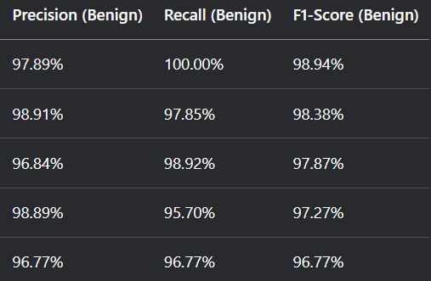
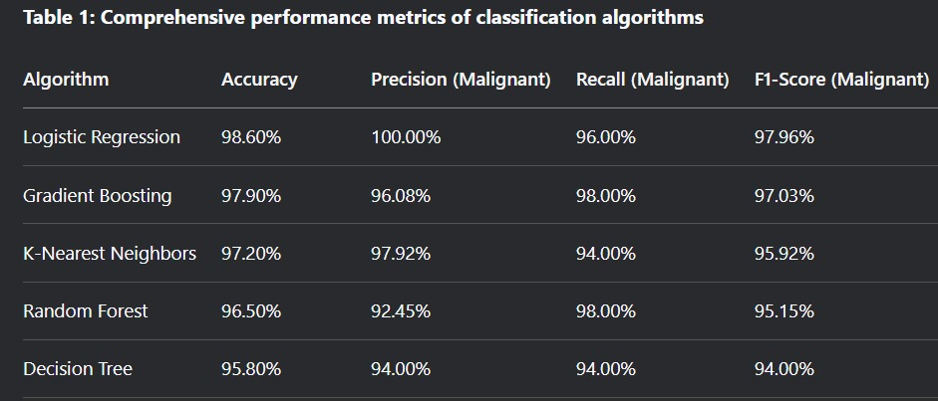
TABLE 1 :

The confusion matrices in Figure 3 illustrate each model's classification patterns :

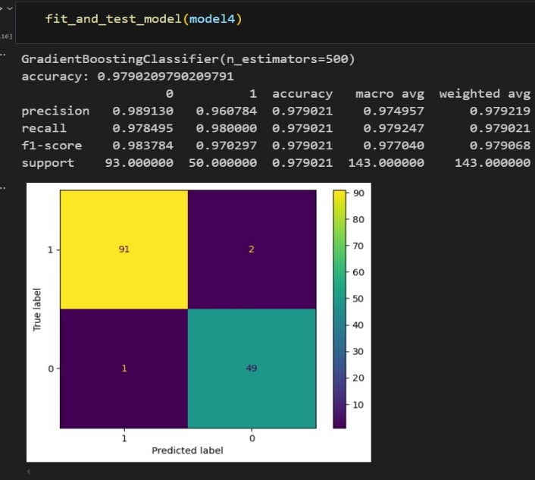
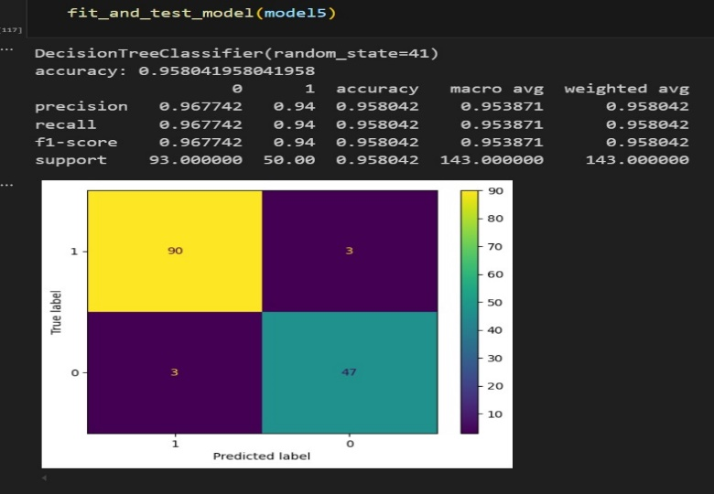
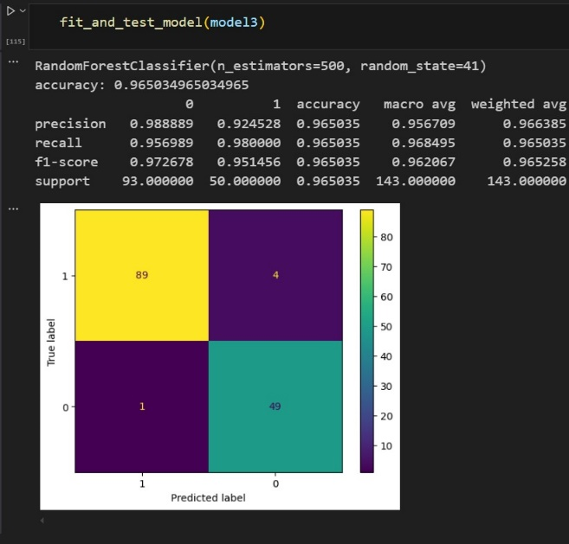
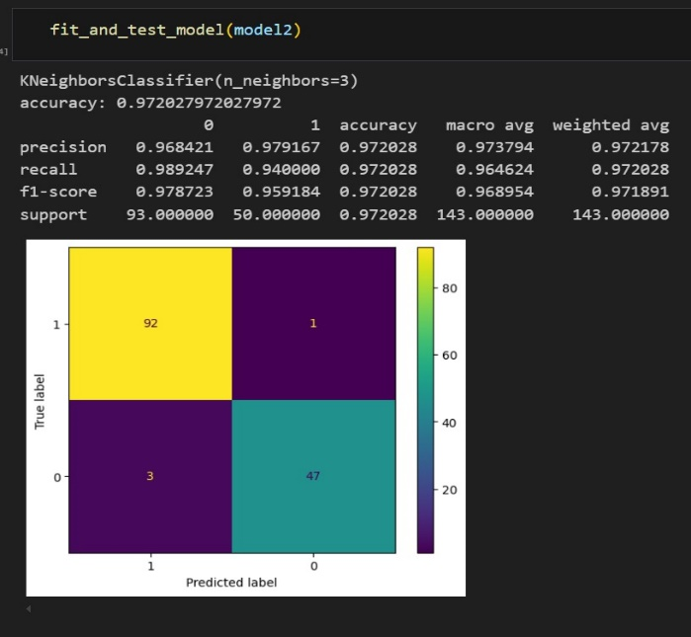
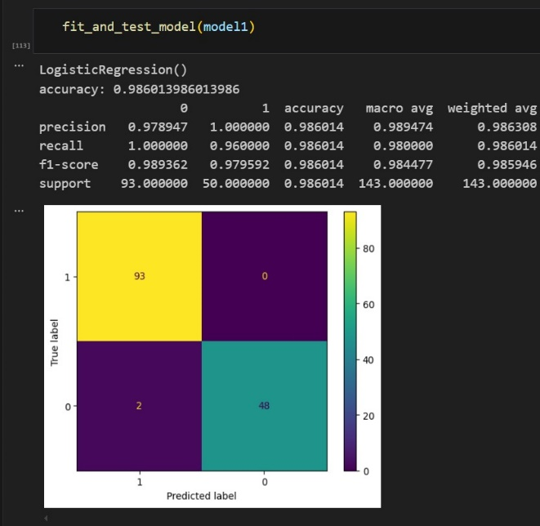

5-discussion:
Diagnosis of breast cancer needs to be accurate, as diagnostic errors—whether false negatives (with delayed treatment and increased mortality) or false positives (with unnecessary biopsies and patient anxiety)—have significant clinical consequences. Radiologists are working under pressure with high volumes of work and subjective interpretation, and the need for accurate, automated decision-support systems is particularly relevant. Machine learning algorithms such as these investigated herein also provide a scalable answer through enhanced diagnostic consistency and reduction of human error.

Among models that were attempted, logistic regression performed best at 98.60% with almost flawless precision (1.000 for the malignancy class) and robust recall (96% for the malignancy). The confusion matrix (Figure 1) spoke to the model's reliability: all 93 benign cases were classified correctly, and just 2 of 50 malignant cases were missed (false negatives). This compromise is clinically significant—while the model did not have any false positives, even infrequent false negatives need to be optimized due to their potentially lethal implications.

These results contradict the supposed advantage of complicated models by demonstrating that basic linear models can work exceptionally well on nicely formatted clinical data when thoroughly preprocessed. However, there remains space for improvement by:

1.Threshold tuning or cost-sensitive learning for achieving greater sensitivity for malignant instances

2.Ensemble techniques (e.g., random forests) for more effectively capturing non-linear feature dependencies

3.Multimodal systems that combine imaging and clinical data for more accurate diagnostic context

Despite these promising results, real-world deployment requires:

1.External validation on diverse datasets for generalizability assurance

2.Careful consideration for clinical integration with model interpretability, computational efficiency, and radiologist workflow compatibility

Socioeconomic implications, including cost-effectiveness of AI-enabled diagnosis and equity of access to these technologies, must also be evaluated in future studies. By consolidating technical innovation with patient-oriented endpoints, such decision-support tools can meaningfully advance precision oncology while minimizing current diagnostic shortcomings.

6 -reference:
- Wu, J., & Hicks, C. (2021). Breast cancer type classification using machine learning. Journal of personalized medicine, 11(2), 61.‏

- Michael, E., Ma, H., Li, H., & Qi, S. (2022). An optimized framework for breast cancer classification using machine learning. BioMed Research International, 2022(1), 8482022.‏

- Islam, T., Sheakh, M. A., Tahosin, M. S., Hena, M. H., Akash, S., Bin Jardan, Y. A., ... & Bourhia, M. (2024). Predictive modeling for breast cancer classification in the context of Bangladeshi patients by use of machine learning approach with explainable AI. Scientific Reports, 14(1), 8487.‏

